CERTIFICATE OF PRESENTATION
We hereby confirm that
Ruben Schols
Gave the following Oral Presentation reference O8.02
The influence of snail host microbiome in trematode parasite resistance
at the 15th International Conference on Molecular Epidemiology and
Evolutionary Genetics of Infectious Diseases
2-5 November 2021, Live and On-demand

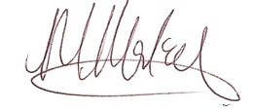

For and on behalf of

